




What is a School-Parent Compact?
It is a written agreement describing how all members of a school community (parents, teachers, principals, and students) agree to share responsibility for student learning. This compact helps build a bridge between the school and home to encourage learning, communication, and achievement for all students.
The purpose of a compact is to list various ways each entity will carryout their commitment to assist students with meeting academic goals. The compact also includes ways the school, staff, and parents will communicate with each other.
The school uses Class Dojo, email blasts, letters sent home, Robo calls, Remind 101, School website, Social Media Accounts, and Parent-Teacher conferences to communicate with families about students’ academic progress.
The principal along with entire staff will ensure that the school environment is safe, secure, and conducive for learning.
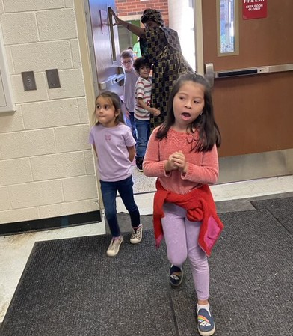

JOINTLY DEVELOPED BY:
The parents, teachers and students of Garrett Elementary developed this school-parent compact. Teachers provided hard copies &
online resources to assist families with homework, parents included various ways to encourage family engagement, and students gave feedback on their learning environment/climate and some of the challenges they face, academically.
Meetings are held bi-annually to review the compact & make changes based on student needs.

Parents are welcomed to contribute comments and offer to volunteer at anytime.

Attending school regularly and on time. Be engaged and actively participate in learning
Completing homework assignments and read a book every night at home to expand vocabulary and increase test scores.

Using innovative ideas and technology to develop regular study habits.
Using Georgia Standards of Excellence (GSE) standards and math vocabulary to

increase knowledge of testing terminology in an effort to increase Lexile reading scores.

GARRETT ELEMENTARY SCHOOL

Stacey Walk, Principal
Dr. Scott, Assistant Principal

School-Parent Compact for Achievement
2025-2026
Revised 9/15/2025
Mission
The mission of T. Harry Garrett Elementary School is to educate the whole child through the integration of the arts throughout the curriculum in order to engage students, enrich content, and to foster appreciation for creativity and diversity.
Vision
Increasing academic achievement for all students and creating a culture of artistic expression through Art, Drama, Dance, and Music.






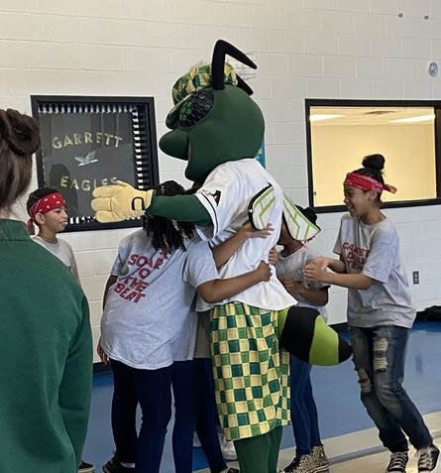

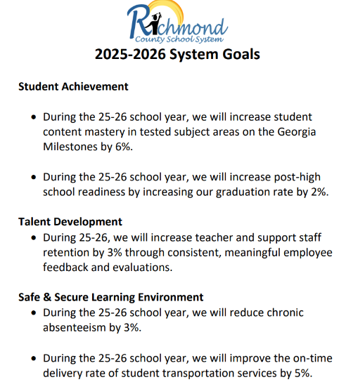

 GOALS SET BY THE PRINCIPAL
By the end of the 2025-26 school year, at least 50% of K-2 students will be on or above grade level according to the EOY iReady reading and math diagnostic.

By the end of the 25-26 school year, we will increase ELA EOG from 24% Proficient or Distinguished to 30% Proficient or Distinguished for 3rd-5th.

By the end of the 25-26 school year, we will increase MATH EOG from 14% Proficient or Distinguished to 21.37% Proficient or Distinguished for 3rd-5th.

By EOY 2025-2026 school year, students’ emotional regulation will have a positive increase from 53% to 65% according to the Panorama Survey.

By the EOY 2025-2026, increase the number of Parent/Community events from 11 to 20 as measured by the school calendar, agendas, and sign-in sheets.

By EOY 2025-2026, increase the number of students absent less than 10% of days from 75.06% to 80% by monitoring attendance data.

TEACHERS, PARENTS,

Teachers & Support Staff Commit to:

Working with students and parents in all academic and social emotional domains, by providing an overview of Georgia Standards of Excellence (GSE) along with attainable goals for each student.
Exploring and utilizing practices that support the development of independent readers. Conduct reading initiatives at school to increase reading proficiency.
Using innovative, hands-on activities and learning techniques in the classrooms.
Providing students and parents with strategies and supplemental materials to increase student achievement at home.

STUDENT PROGRESS COMMUNICATION
HOME COMMUNICATION FOLDERS CLASS DOJO
INFINITE CAMPUS PARENT PORTAL SCHEDULED PARENT/TEACHER CONFERENCES

STUDENTS-TOGETHER FOR SUCCESS

Students Commit to:

Attending school regularly and on time. Be engaged and actively participate in learning
Completing homework assignments and read a book every night at home to expand vocabulary and increase test scores.
Using innovative ideas and technology to develop regular study habits.
Using Georgia Standards of Excellence (GSE) standards and math vocabulary to increase knowledge of testing terminology in an effort to increase Lexile reading scores.

